Experiment Title:
HTTP Client–Server Configuration in Java

Introduction
Client–Server architecture is a fundamental concept in Computer Networks where a client sends requests and a server responds to those requests over a network.
The HTTP (HyperText Transfer Protocol) is widely used for communication between web clients (like browsers) and servers. It follows a request–response model, where the client sends an HTTP request and the server returns an HTTP response.
In this experiment, a simple HTTP server is created using Java’s built-in HttpServer class, and a client is implemented using HttpURLConnection to establish communication between them.

Procedure (Code)
Step 1: Create HTTP Server
import com.sun.net.httpserver.HttpExchange;
import com.sun.net.httpserver.HttpHandler;
import com.sun.net.httpserver.HttpServer;
import java.io.*;
import java.net.InetSocketAddress;

public class SimpleHttpServer {
public static void main(String[] args) throws Exception {
HttpServer server = HttpServer.create(new InetSocketAddress(5000), 0);

server.createContext("/", new MyHandler());
server.setExecutor(null);
server.start();

System.out.println("Server started at http://localhost:5000");
}

static class MyHandler implements HttpHandler {
public void handle(HttpExchange exchange) throws IOException {

String response = "HTTP Server running successfully on port 5000.\nClient-Server communication established.";

exchange.getResponseHeaders().set("Content-Type", "text/plain");

byte[] responseBytes = response.getBytes();

exchange.sendResponseHeaders(200, responseBytes.length);

OutputStream os = exchange.getResponseBody();
os.write(responseBytes);
os.close();
}
}
}

Step 2: Create HTTP Client
import java.io.*;
import java.net.*;

public class SimpleHttpClient {
public static void main(String[] args) throws Exception {

URL url = new URL("http://localhost:5000/");
HttpURLConnection conn = (HttpURLConnection) url.openConnection();

conn.setRequestMethod("GET");

int status = conn.getResponseCode();
System.out.println("Response Code: " + status);

BufferedReader in = new BufferedReader(
new InputStreamReader(conn.getInputStream())
);

String inputLine;
System.out.println("Response from server:");

while ((inputLine = in.readLine()) != null) {
System.out.println(inputLine);
}

in.close();
conn.disconnect();
}
}

Step 3: Execution Steps
- Compile both files
- Run the server
- Run the client
- Observe the communication output

Output
Console Output
Server started at http://localhost:5000
Response Code: 200
Response from server:
HTTP Server running successfully on port 5000.
Client-Server communication established.

Screenshot
- Server running terminal

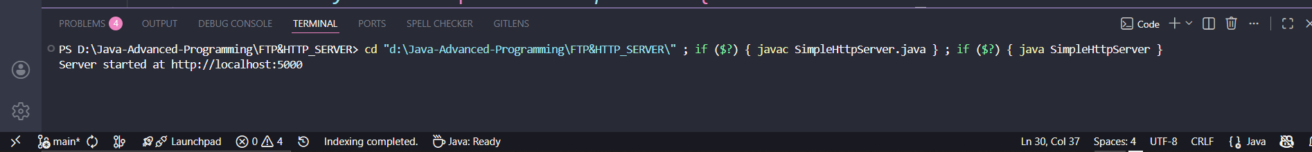

- Client output terminal
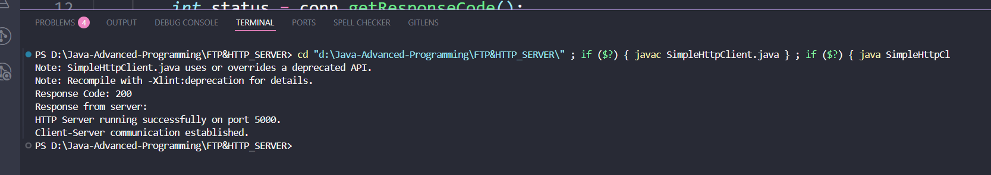

Conclusion
In this experiment, a simple HTTP client–server communication system was successfully implemented using Java. The server handled incoming HTTP requests and responded with appropriate messages, while the client successfully sent requests and received responses.
This experiment helped in understanding the working of the HTTP protocol, client–server architecture, and basic network communication in Java.

